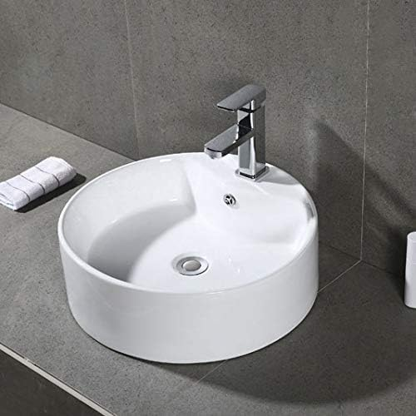

$39

Safavieh BSK5402A Solea Collection Mira Bathroom Basin Sink, White